iREVOLUTION – DATA DRIVEN EXPLORATION OF APPLE IPHONE IMPACT IN INDIA

INTRODUCTION:

iRevolution of a data driven exploration of apple iphone impact in India is being described in our project.

OVERVIEW:

1. The apple iphone is expressed as a prominent player among the top smartphones markets.
2. Apple iphones shows us a special view to increase the market share.
3. Especially the apple iphone gives a significant presence in India by large amount of adoption towards the smart phone apple gadgets.

PURPOSE:

The project is focussing on using digital tools and platform to empower individuals and communities in various aspects of our lives.

PROBLEM DEFINITION AND DESIGN THINKING

:EMPATHY MAP:

: 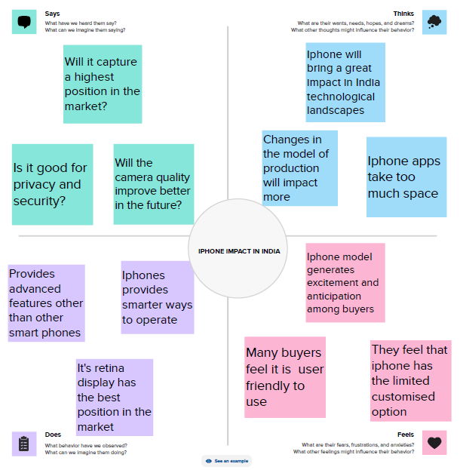

BRAIN STORMING:

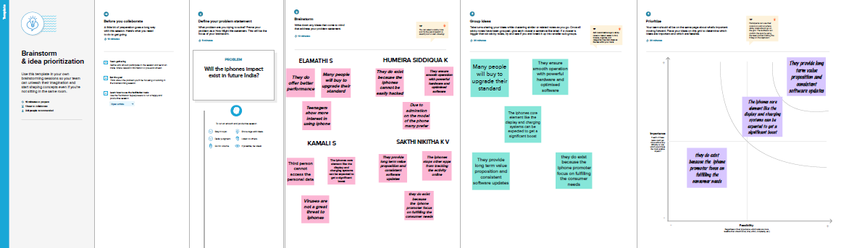

RESULT:

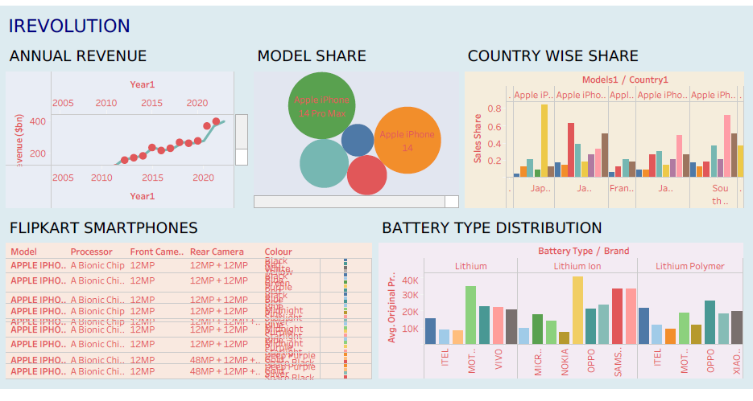

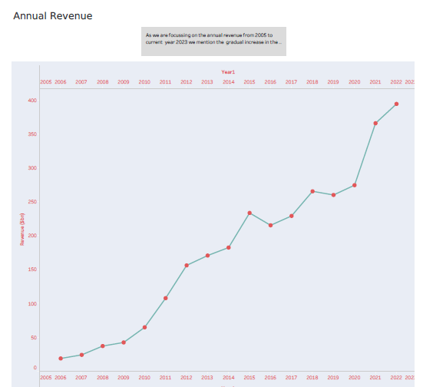

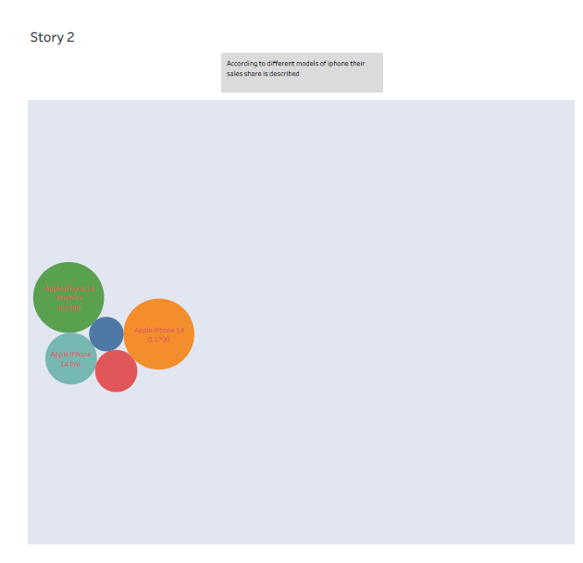

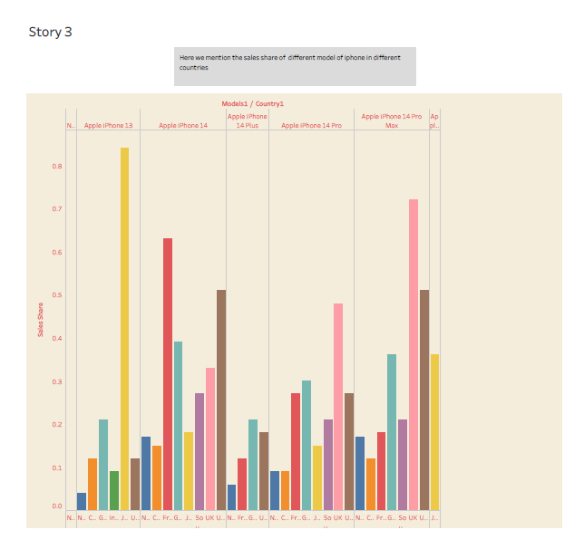

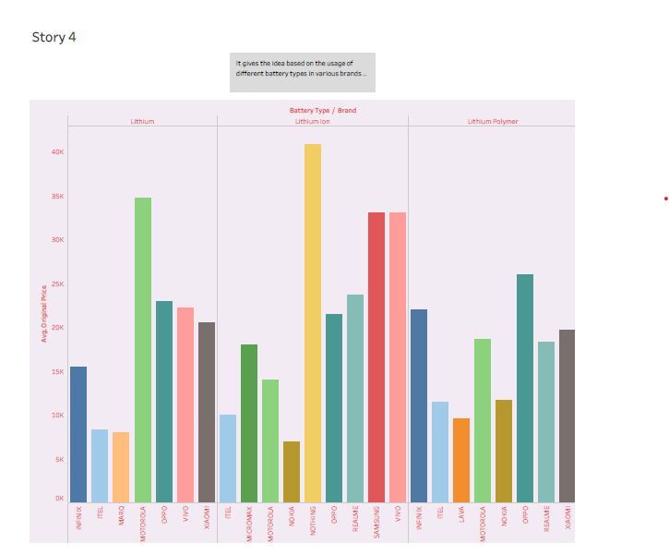

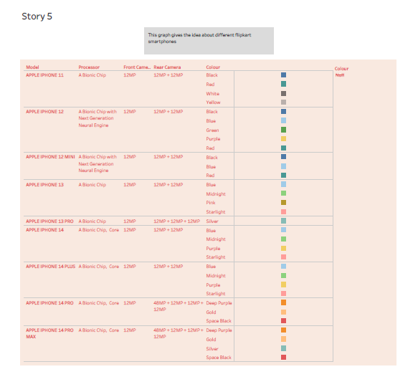

ADVANTAGES:

It enables us to access :

1.Information

2.communication

3.Collaboration

4.Provides platform for civil engagement and activism.

DISADVANTAGES:

1.Disadvantages could include issues with privacy and data security .

2.The digital divide may exclude certain communities and the potential for the misuse or manipulation of technology.

APPLICATIONS :

The irevolution project can be applied in areas such as

1. Health care
2. Education
3. Transportation
4. Communication
5. Government

*CONCLUSION :*

1. The irevolution project holds immense potential for positive change in various areas of our lives
2. While there are challenges to address such as privacy and misinformation , the benefits of increased connectivity ,access of information
3. The technological advancements outweigh the drawbacks
4. Its important embrace irevolution responsibly and ensure that it is used to empower individuals ,foster inclusitivity and a better future for all.

FUTURE SCOPE :

1. It has the potential to continue advancing technology, connectivity and social change.
2. As the technology continues to evolve we can expect even more applications and advancement in areas like artificial intelligence, virtual reality and internet things.
3. This could enhance automation, personalised experience and improved efficiency across various industries
4. This can contribute to the development of smart cities, sustainable solutions,and global connectivity.